Come Join Us

September 26, 2018

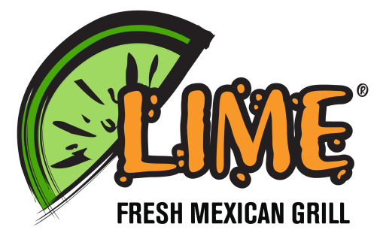Anytime from 5-9 PM

**Lime Fresh Mexican Grill**

**12516 SW 88th Street**

**Miami, FL 33186**

Make sure you mention

Bridgeprep Academy of Village Green at the Register

Come Join Us

September 26, 2018

Anytime from 5-9 PM

**Lime Fresh Mexican Grill**

**12516 SW 88th Street**

**Miami, FL 33186**

Make sure you mention

Bridgeprep Academy of Village Green at the Register